**SPRINT-1**

**CREATING AN ACCOUNT IN CLARIFAI**

|  |  |
| --- | --- |
| **TEAM ID** | PNT2022TMID53703 |
| **PROJECT DOMAIN** | INTERNET OF THINGS |
| **PROJECT TITLE** | IOT BASED SMART CROP PROTECTION SYSTEM FOR AGRICULTURE |
| **DATE** | 29 OCTOBER 2022 |

To detect the animals and birds we are using an open-source platform Clarifai

To use this service in the project we need to sign up for this.

# CLARIFAI

Clarifai provides an end-to-end platform with the easiest to use UI and API in the market Clarifai Inc. is an [artificial intelligence](https://en.wikipedia.org/wiki/Artificial_intelligence) (AI) company that specializes in [computer vision](https://en.wikipedia.org/wiki/Computer_vision) and uses [machine learning](https://en.wikipedia.org/wiki/Machine_learning) and [deep neural](https://en.wikipedia.org/wiki/Deep_learning#Deep_neural_networks) [networks](https://en.wikipedia.org/wiki/Deep_learning#Deep_neural_networks) to identify and analyse images and videos. The company offers its solution via [API](https://en.wikipedia.org/wiki/Application_programming_interface), mobile [SDK](https://en.wikipedia.org/wiki/Software_development_kit), and [on-premise](https://en.wikipedia.org/wiki/On-premises_software) solutions.

# STEP 1:

Open Clarifai portal in web browser

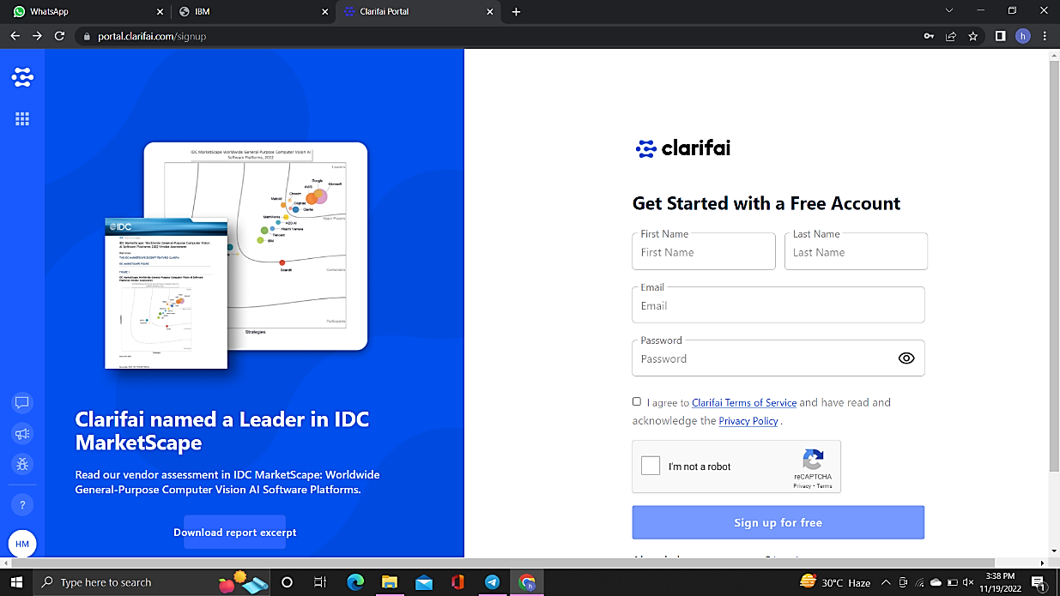

# STEP 2:

Signup using the required user mail and password

**STEP-3:**

Finally created an account

